# **Technical Design Document For storeLBOtester.sh**

Table of Contents

**Technical Design Document For storeLBOtester.sh** 1

0 PREFACE 3

0.1 PURPOSE OF THIS DOCUMENT 3

**The Script**: How the script works 4

How to use Exchange 4

**Structure:** What is in the Script 8

How to understand script 8

**Where is the script:** How can I find and run the script 10

How to use storeLBOtester.sh (you only do this once) 10

# 0 PREFACE

# 0.1 PURPOSE OF THIS DOCUMENT

#1 This document is a generic Technical Document for use by TSC. It provides guidance and template material which is intended to assist the relevant management or technical staff in accessing the resources created for storeLBOtester.sh script.

storeLBOtester.sh currently at its most basic phase, a script written in bash to test the network of stores by ensuring pingable status of currently Marks stores and running troubleshooting with Hammer.

# **The Script**: How the script works

This describes the process of using the script and what it does

## How to use Exchange

1. You can launch the script with ./scriptname or bash scriptname
2. The script reads input from the user in the form ### ie 190 and proceeds to run commands directed to the store.

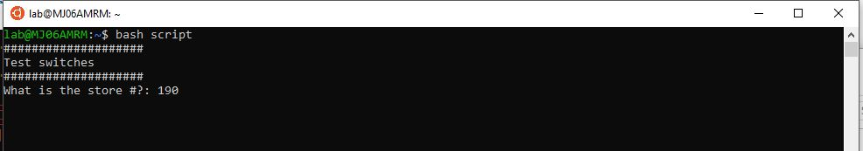

Figure bash to run the script then the store number

1. If step 2 is invalid, because no error handling has been placed in the beta stage you should see the image attached. Notably the ping will fail due to unknown host and the IP field will be blank. You can exit this by hitting Ctrl C or Ctl D to run the script again.

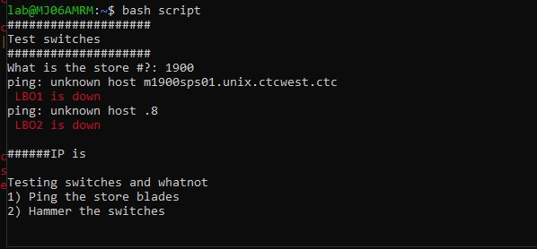

Figure error for invalid 1900 store number

1. If step 2 succeeds; if the store # is valid and pingable, you will see results in the image attached. It will run 2 pings on the store, and lets you know the status in color code red or green for down or up respectively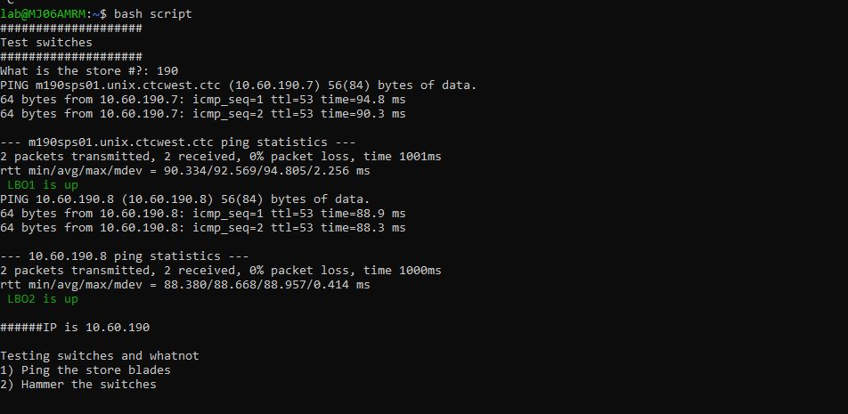

Figure An LBO test on store 190 shows both are up and the IP of the store router

1. Next option will prompt you on a loop to either select you options 1 or 2 for the section testing switches and whatnot. More features to be added in the future. But if the option selected is 1(to ping the blades), all blades will be tested with a color code red or green for down or up respectively 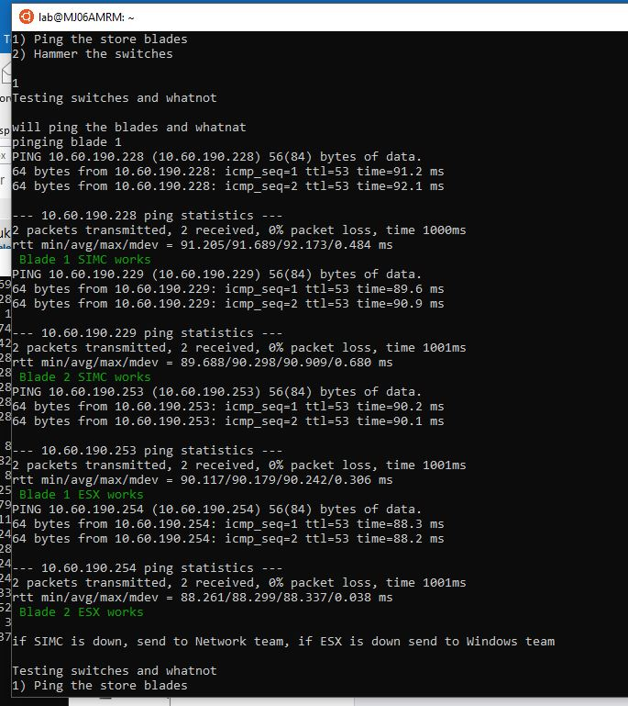

Figure Pinging the SIMC and ESX blades at the store 190, all work

1. Option 2 (Hammer the switches) will prompt you some questions before hammering the switches. This kills the services on the blades and could potentially disrupt the stores if not used properly. Also make sure that the PLs know. The script will detect if the Hammer is failed and run the hammer command but for now only Hammer status can be tested in the script.

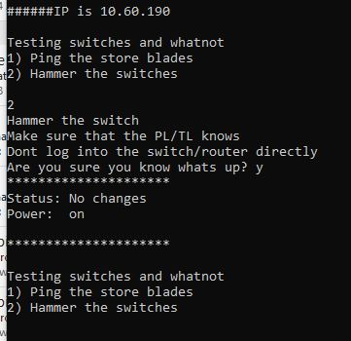

Figure Hammer status on the store 190 show a status up

# **Structure:** What is in the Script

This script was initially created for just me and may lack some conveniences. The goal is that is can be improved on later and probably refactored. It currently uses conditions majorly to run its decision structure.

## How to understand script

1. The first section includes declaring the shebang and setting variables for color. A snippet for the variable was set but commented out

advised store to refresh page to resolve issue 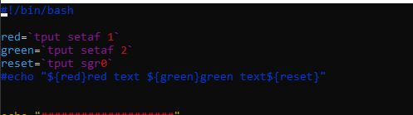

Figure setting the variable for colors

1. The script then takes the Store number to use it for conditions, testing and pinging

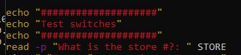

Figure greeting message and input for store #

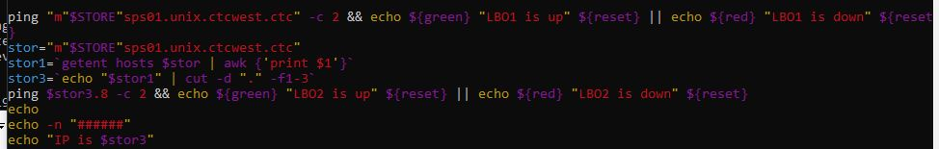

Figure pinging the blades

1. The script then runs a loop to test the Blades in the store using the .228 .229 .254 .253 addresses

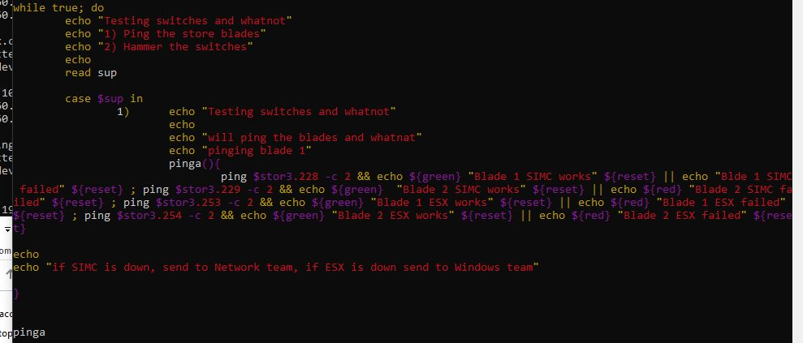

Figure Testing the status of the blades

1. The second option of the loop runs tests on the hammer status. It can determine successful hammer status using the keywords “power on” which implies a success hammer status. If failed it will run the hammer stop command (this has been commented out for now)

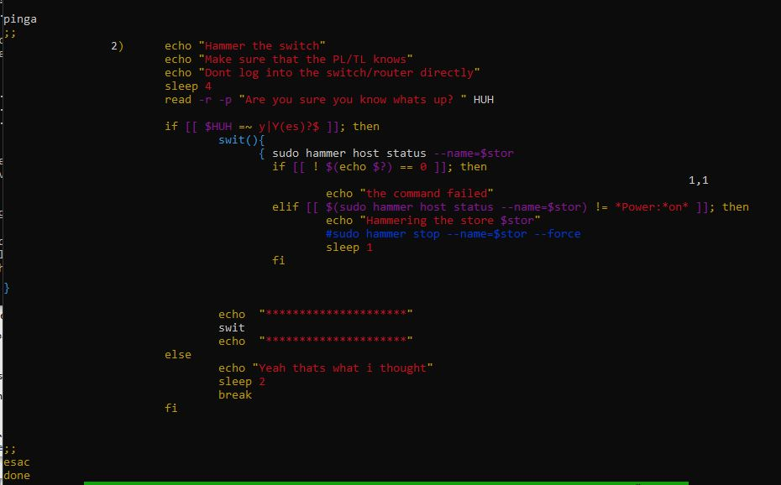

Figure Testing the status of hammer

# **Where is the script:** How can I find and run the script

Hopefully we can get a shared VM in the future where we can share and receive documents but for now you may either have to copy the script and save on your computer. The script for now is 

## How to use storeLBOtester.sh (you only do this once)

1. You can copy this script attached then past it into your Linux vm. First create your file in your linux VM after you ssh into it putty

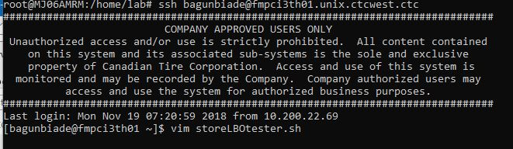

Figure Login to VM and create a file with vim

1. Then enable write by typing i to insert. Then paste the contents of the script into it. Type escape to exit insert mode and type :wq to save and exit]

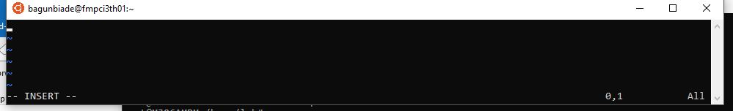

Figure Type i after you open vim to begin INSERT mode

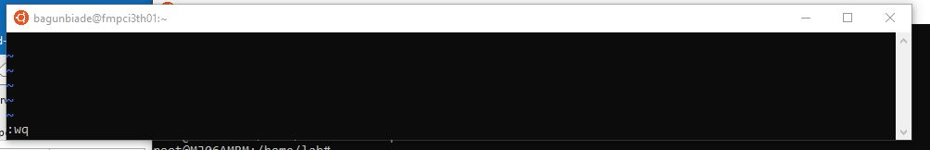

Figure type :wq to save and exit

1. Hopefully when things are easier users can just scp into their VMs

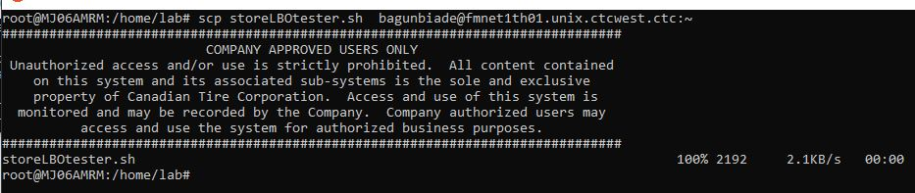

Figure scp into your VM